# Prototypes

## Ultra-Sonic Range sensor prototype

In the search for the different methods of how a user could interact with Arduino using gestures, one such method was using an Ultra-Sonic Range sensor. To start the experiment, we had first borrowed equipment from the lab at King William which includes:

* A buzzer
* Wires
* One LED light
* Arduino
* Breadboard
* Computer system

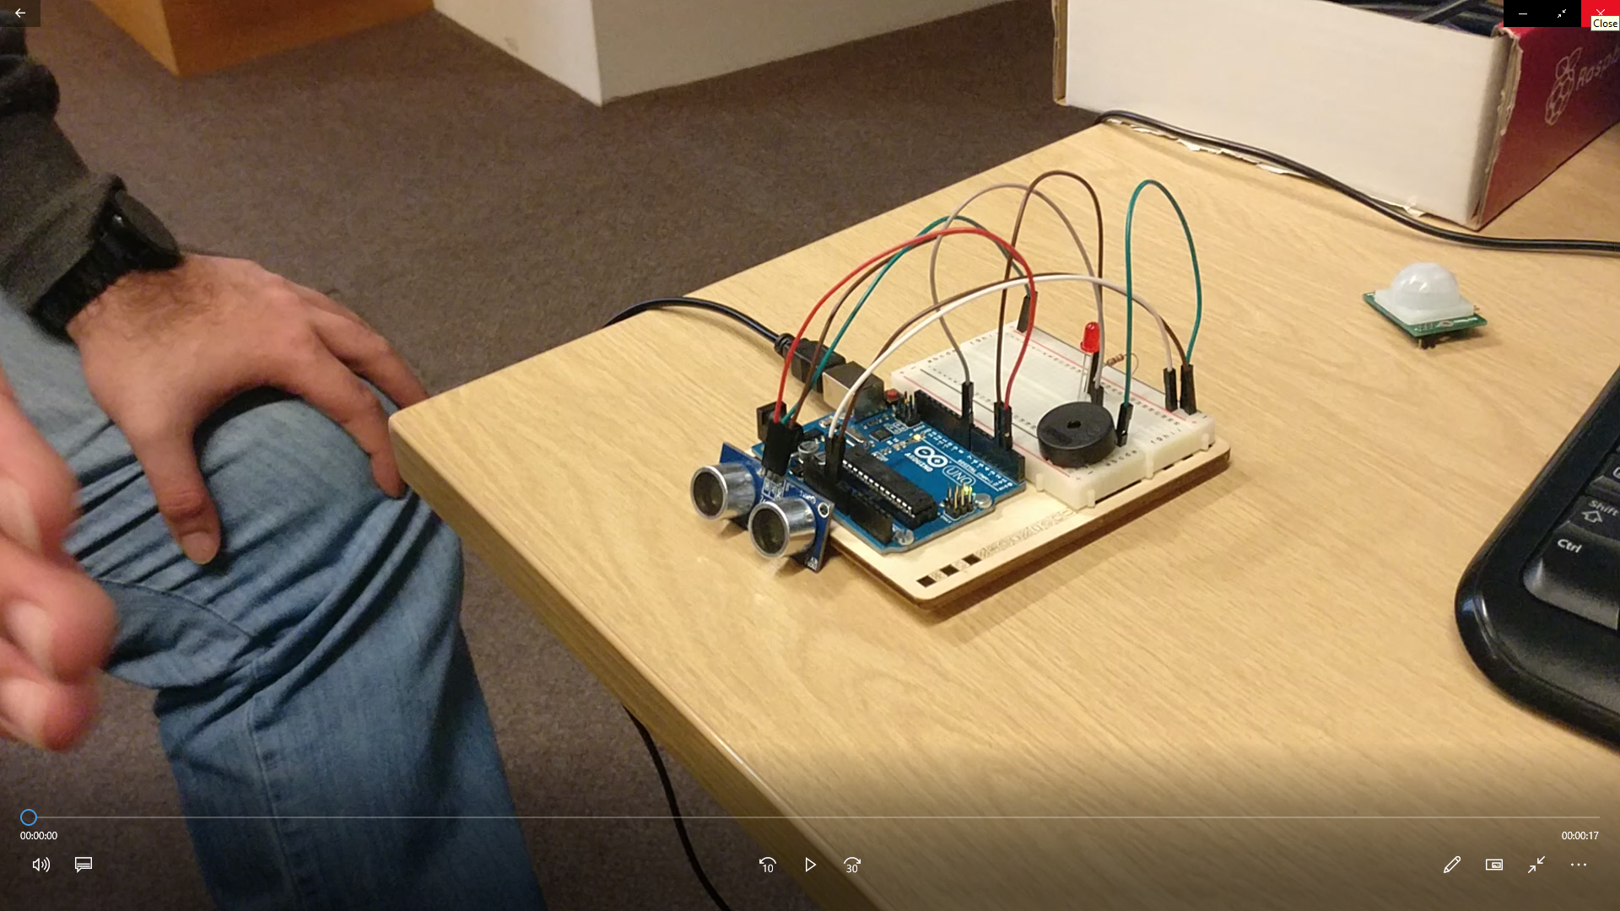

The experiment was designed to test to see how the Ultra-Sonic sensor registers hand movement and how it could be used for the art installation. Using the source code provided by one of our team members Daniel, the pitch of the buzzer can be controlled using an Ultra-Sonic Sensor to create a Theremin. The distance between the sensor and the hand feeds back into the command console, which helps show that the sensor is working.

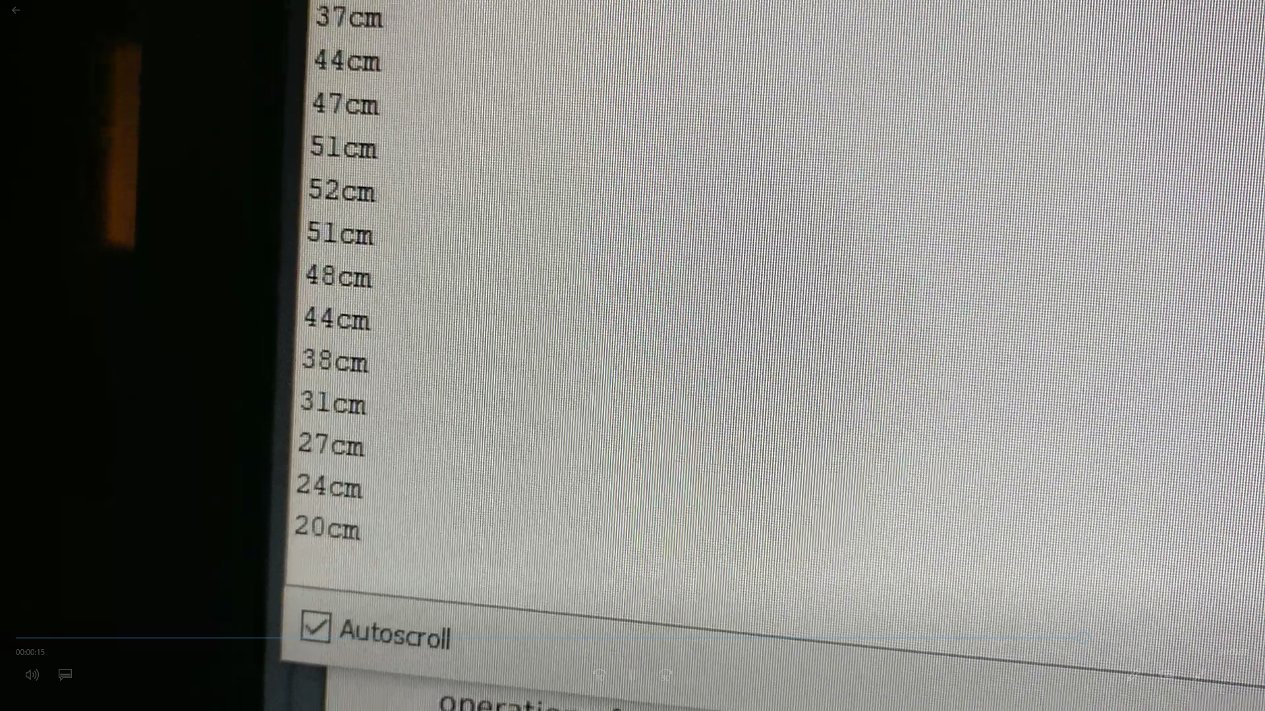

We found that the Ultra-Sonic sensor could only sense movement along a linear path. The constraints that the Ultra-Sonic sensor had, made the Ultra-Sonic sensor a less preferred choice for our method of interaction as it did not meet the quality of user interaction that we desired. We decided to experiment with other methods of interaction such as the Kinect that would better suit our demands.

However, the Ultra-Sonic sensors were a good alternative to use in case we could not get the art installation to work with the Kinect.